[](http://www.google.co.uk/url?sa=i&rct=j&q=&esrc=s&source=images&cd=&cad=rja&uact=8&ved=0CAcQjRw&url=http://www.ea.com/connect-4&ei=0hGDVOXHE4OAUf-5hOgP&bvm=bv.80642063,d.ZWU&psig=AFQjCNGHabRYYyMoW2MalCkAxo2eAhU_HA&ust=1417962199405416)

**Connect 4**

Your task is to create a Connect 4 game of your own like the example. Your game should do the following:

Use a 7 Wide, 6 High grid.

Allow for Two players.

Allow them to enter their names.

Have a button to start/restart the game.

Have a way of deciding who goes first.

**Extension Tasks**

Use Graphics rather than just the letters ‘O’ and ‘X’.

Draw a Line through the win with graphics.

Allow for choosing to play against the computer.

Add a score system to record wins for each player.

Work out the percentage of wins for each player.

Surprise me with Sound, Speech, Animated Graphics and Mouse Control.

**Hand In Deadline – Anytime if you actually enjoy coding and are any good at it!**

You must submit a commented program code listing and screenshots of your program working.

**Example**

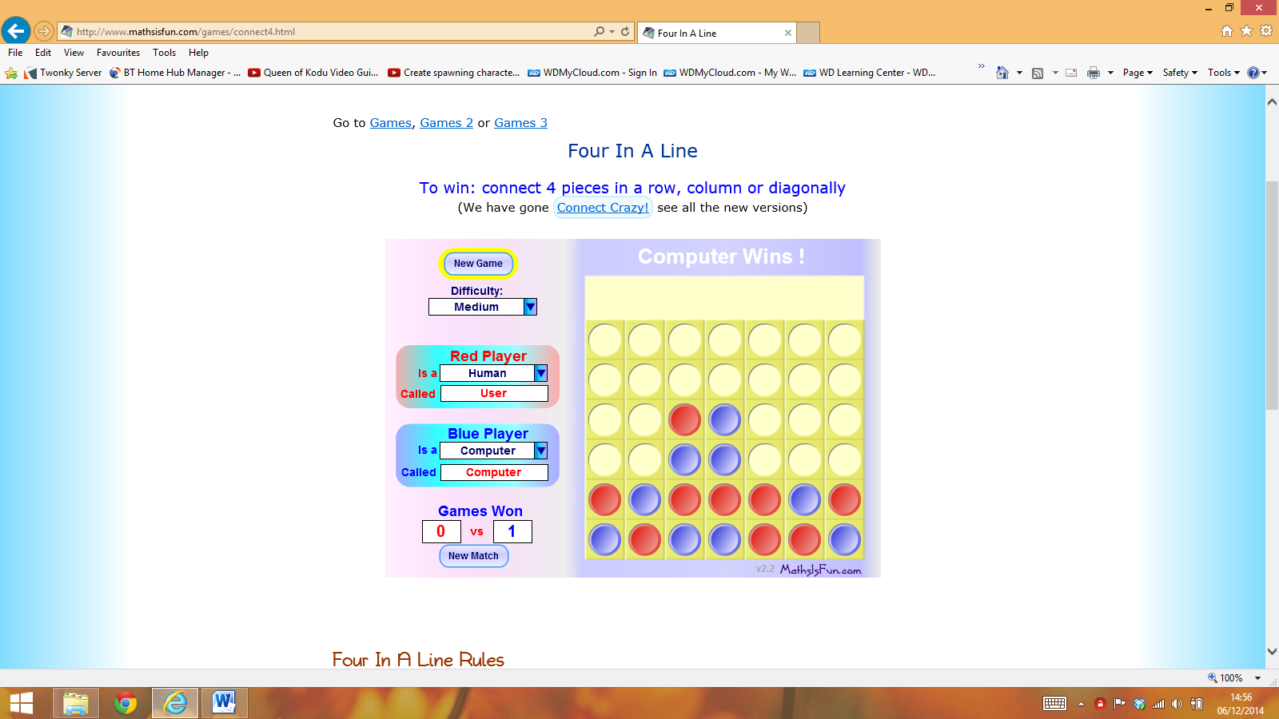

**Playing Against the Computer**

The game was first known as “The Captain's Mistress", but was released in its current form by Milton Bradley in 1974. In 1988 Victor Allis solved the game, showing that with perfect play by both players, the first player can always win if he plays the middle column first, and if he chooses another column first the second player can always force a draw.

**Method**

You will need to keep a 7x6 array and the method is much the same as for Noughts and Crosses; store a 10 for one player and a 1 for the other player in the grid.

You have 6 Rows, 7 Columns, 6 R-L Diagonals and 6 L-R Diagonals to check – 25 in total.

There are 24 winning Row positions, 21 winning Column positions, 12 R-L Diagonal winning positions and 12 L-R Diagonal winning positions – 69 in total.

|  |  |  |  |  |  |  |
| --- | --- | --- | --- | --- | --- | --- |
| 1 | 1 | 1 | 1 | 1 | 1 | 1 |
| 2 | 2 | 2 | 2 | 2 | 2 | 2 |
| 3 | 3 | 3 | 3 | 3 | 3 | 3 |
| 4 | 4 | 4 | 4 | 4 | 4 | 4 |
| 5 | 5 | 5 | 5 | 5 | 5 | 5 |
| 6 | 6 | 6 | 6 | 6 | 6 | 6 |

|  |  |  |  |  |  |  |
| --- | --- | --- | --- | --- | --- | --- |
| 1 | 2 | 3 | 4 | 5 | 6 | 7 |
| 1 | 2 | 3 | 4 | 5 | 6 | 7 |
| 1 | 2 | 3 | 4 | 5 | 6 | 7 |
| 1 | 2 | 3 | 4 | 5 | 6 | 7 |
| 1 | 2 | 3 | 4 | 5 | 6 | 7 |
| 1 | 2 | 3 | 4 | 5 | 6 | 7 |

|  |  |  |  |  |  |  |
| --- | --- | --- | --- | --- | --- | --- |
| 3 | 4 | 5 | 6 |  |  |  |
| 2 | 3 | 4 | 5 | 6 |  |  |
| 1 | 2 | 3 | 4 | 5 | 6 |  |
|  | 1 | 2 | 3 | 4 | 5 | 6 |
|  |  | 1 | 2 | 3 | 4 | 5 |
|  |  |  | 1 | 2 | 3 | 4 |

|  |  |  |  |  |  |  |
| --- | --- | --- | --- | --- | --- | --- |
|  |  |  | 1 | 2 | 3 | 4 |
|  |  | 1 | 2 | 3 | 4 | 5 |
|  | 1 | 2 | 3 | 4 | 5 | 6 |
| 1 | 2 | 3 | 4 | 5 | 6 |  |
| 2 | 3 | 4 | 5 | 6 |  |  |
| 3 | 4 | 5 | 6 |  |  |  |

The ‘Brute Force’ and inelegant approach would to test each of the 69 winning positions for a score or 4 or 40. A better approach is to test the 25 Rows, Columns and Diagonals looking for a score of 4 or 40 but in 4 contiguous positions. So you will need a counter to check that they are contiguous positions.

* To begin (Sub Form_Load) the buttons need to be disabled.
* The start button will read who is going first and set a variable for this then clear all of the array elements to 0, clear the button displays, enable all of the buttons and reset all of the counters.
* After each go you need to store a 1 or 10 in the correct array position, print an ‘X’ or ‘O’ to the button, test for a win/draw, toggle whose go it is, check for a win, count how many goes there have been so far and disable the button selected.
* You will need to test 6 Rows, 7 Columns, 6 R-L Diagonals and 6 L-R Diagonals. If the total of any is 4 or 40, in four contiguous positions we have a winner. If they are not contiguous or there is no winner then reset this counter. If we do add up to 4 or 40 on a line you must not do the next test because we have found a winner already. If you do not have a winner you must reset the counter of how many goes we have had. If we do not have a winner after 48 goes (use a counter) then it is a draw.
* **Method 2** - The method I used was a bit different. I used a 4x4 block that moves, which means you only have to do 12 tests and I can use the noughts and crosses trick; Total=4 means Player 1 wins and Total =40 means Player 2 wins.